Proletarians of all countries, unite!

On the recent meeting between Putin and Biden

There was a noteworthy meeting between Joe Biden and Vladimir Putin in Geneva on 16 June 2021, following the annual G7 summit on June 13 in Cornwall. After the bilateral meeting between the heads of Yankee- and Russian imperialism, Biden said initially a very crucial thing about the status quo and the relations between the sole hegemonic superpower he is heading and the atomic superpower: "President Putin and I had a — share a unique responsibility to manage the relationship between two powerful and proud countries — a relationship that has to be stable and predictable. And it should be able to — we should be able to cooperate where it’s in our mutual interests. [...] I told President Putin my agenda is not against Russia or anyone else; it’s for the American people [i.e. Yankee imperialism to maintain as the sole hegemonic superpower, in the words of its head] [...] The bottom line is, I told President Putin that we need to have some basic rules of the road that we can all abide by. I also said there are areas where there’s a mutual interest for us to cooperate, for our people — Russian and American people — but also for the benefit of the world and the security of the world. One of those areas is strategic stability. [...] now I can tell you what I was intending to do all along, and that is to discuss and raise the issue of strategic stability and try to set up a mechanism whereby we dealt with it."

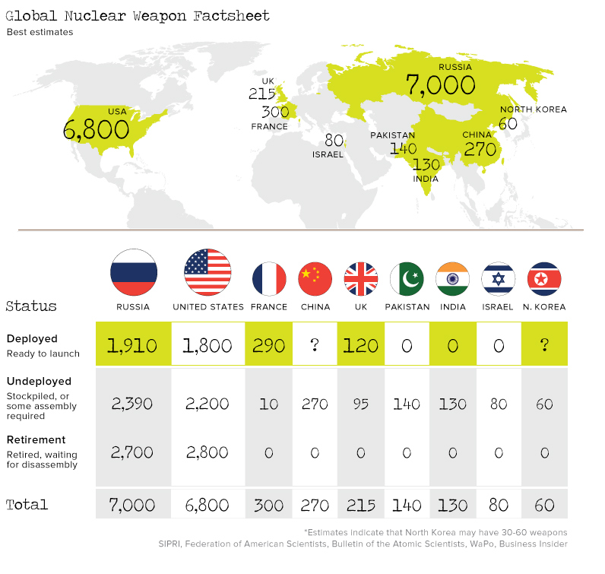
Stability and predictability - cooperation - mutual interests and mechanism for strategic stability, the key issues of yankee-russian-collusion against the peoples of the world. "Strategic stability" between the two (see Boxes 1 and 2) against all others, not "linking China's economic growth with its military growth". The basis of the collusion is clear. That is the common interest that both imperialists have against those who want to advance towards a comparable power, that is the common interest of which Biden speaks to Putin, on which he acts to apply his maxim divide et impera, so that the rival powers do not unite against U.S. imperialism. In order to prevent in time the appearance of a threat from another imperialist power that could challenge the U.S. hegemony in Eurasia, hegemony over a continent defined by the U.S. itself as the strategic centre of its world hegemony. For this reason, both need to reach a more general agreement, because the situation is so unstable that at any point of conflict a spark could ignite a third world war. That is why, since decades before the bankruptcy of Soviet revisionism and then with the current Russia, atomic superpower, the contradiction between both is managed seeking to ease the old points of conflict to ignite new ones, that is the characteristic of the collusion and struggle between U.S. imperialism and Russian imperialism, see in this regard our article "On Afghanistan".

Interimperialist contradiction develops in collusion and struggle and is resolved by imperialist war and imperialist world war. The spoils are the oppressed nations. Chairman Mao's speech of January 1957, on the international situation where he refers to the Suez Canal incident in 1956, he tells us that in the wars of imperialist aggression two contradictions and three forces are expressed, it is important because it expresses his thesis of Three Worlds in formation. Chairman Gonzalo specifies that the historically principal contradiction is oppressed nations-imperialism, which may temporarily become secondary in the case of an imperialist war, but to become principal again until the definitive sweeping away of imperialism and world reaction.

Putin agreed upon this, saying: "I believe that both parties, including the United States, seek to find common ground and find solutions." Solutions mentioned by Biden as: "arms control measures [...] to reduce the risk of unintended conflict." Putin explained: "The US and Russia hold special responsibility for strategic stability in the world judging by the fact that we are technologists to nuclear powers [...] We realize this responsibility and President Biden took a responsible and timely decision to extend the Neustadt Treaty [Even the protocol says Neustadt, it is obviously New START what is being meant.] by another five years".

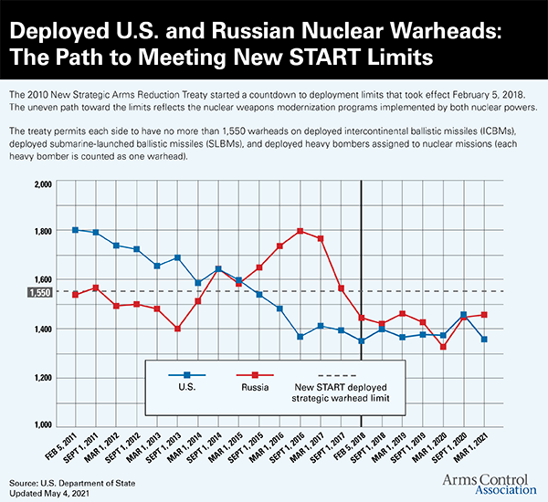
The New Strategic Arms Reduction Treaty (New START) capped accountable deployed strategic nuclear warheads and bombs at 1550, and each heavy bomber is counted as one warhead. Deployed intercontinental ballistic missiles (ICBMs), submarine-launched ballistic missiles (SLBMs), and heavy bombers assigned to nuclear missions are limited to 700. Deployed and non-deployed ICBM launchers, SLBM launchers, and bombers are limited to 800. This number includes test launchers and bombers and Trident submarines in overhaul. New START monitors non-deployed ICBMs and SLBMs and provide for continuous information on their locations and on-site inspections to confirm that they are not added to the deployed force. For deployed ICBMs and SLBMs, the number of warheads counted is the actual number of re-entry vehicles (RVs) on each missile (an RV protects the warhead as it re-enters the atmosphere from space; it can carry only one warhead). Each deployed ICBM, SLBM, and nuclear-capable bomber is counted as one delivery vehicle against the 700 limit. Each deployed and non-deployed missile launcher or bomber is counted as one launcher against the 800 limit. Non-deployed missiles are monitored but not limited in number. Current and planned U.S. missile defence programs are not constrained by New START. The preamble acknowledges the “interrelationship between strategic offensive arms and strategic defensive arms” and that “current strategic defensive arms do not undermine the viability and effectiveness of the strategic offensive arms of the Parties.” New START does not prohibit either side from deploying conventional warheads on long-range ballistic missiles.

Biden said "the tone of the entire meetings [...] was good, positive" and Putin agreed: "there has been no hostility. On the contrary, our meeting took place in constructive spirit. Indeed we have the right assessments on a number of issues. First, both sides expressed their intention to understand each other, and to seek common ground, talks were quite constructive." The meeting and its ambitions seems to a bit problematic for other imperialist powers. German "Tagesschau" tried to play down the meeting reducing it to the return of the ambassadors and the British "Guardian" focused on animosities between Putin and Biden like the "Killer"-slander or the Navalny issue. Mainly German and French imperialism did act accordingly, e.g. at the Second Berlin Conference on Libya on June 23 or at the EU summit on June 25. The Chinese Xinhua created the headline "Putin lashes out at U.S." - all this rage arises from the fear of disadvantages as a result of the Biden-Putin-Meeting.

Biden issued "certain critical infrastructure should be off limits to attack [...] by cyber or any other means. [...] 16 specific entities; 16 defined as critical infrastructure under U.S. policy, from the energy sector to our water systems." Putin replied: "We face the similar threats [...] I don’t think that the United States authorities are interested in such manipulations. We need to get rid of all kinds of insinuations and innuendo, and we should launch the expert work for the benefits of the United States and the Russian Federation. We have reached an agreement in principle and Russia is ready to do that."

Both stated that they "[...] agreed to pursue diplomacy related to the Minsk Agreement", as Biden formulated in his statement. And on other issues related to imperialism-oppressed nations and interimperialist contradiction, wars they wage, Biden upholds "to preserve and reopen the humanitarian corridors in Syria [...] how to build it and how it is in the interest of both Russia and the United States to ensure that Iran [...] does not acquire nuclear weapons. We agreed to work together there because it’s as much interest — Russia’s interest as ours. And to how we can ensure the Arctic remains a region of cooperation rather than conflict. [...] shared effort of preventing a resurgence of terrorism in Afghanistan." And he quoted Putin saying during the meeting "that he was prepared to, quote, “help” on Afghanistan [...] help on — on Iran; and help on [...] Syria and Libya."

"This is not a ‘kumbaya’ moment [...] But it’s clearly not in anybody’s interest — your country’s or mine — for us to be in a situation where we’re in a new Cold War." - Struggle and Collusion that's what it is, vulgarly expressed by the head of Yankee imperialism.

Biden seems to be friendly, cosy and nice in this case, but he implies that Russia and the Yankees are not on the same level as they were during the cold war, even Russia is still a nuclear superpower, the U.S. are the sole hegemonic superpower and no one can compete on the same level with them in politics, economics and the military yet [this is implicit by the tone of the statements of both, Biden more and Putin less aggressive and suggestive]. Hence, he threatens Russia with socialimperialist China: “You got a multi-thousand-mile border with China. China is moving ahead, [...] seeking to be the most powerful economy in the world and the largest and the most powerful military in the world. You’re in a situation where your economy is struggling, you need to move it in a more aggressive way, in terms of growing it. And you — I don’t think he’s looking for a Cold War with the United States.” It is noteworthy that Biden used quite aggressive gestures like putting of his suite and yelling at journalists: “If you don’t understand that, you’re in the wrong business.” Divide et impera!

This meeting was of great importance, because it set their road ahead. It proved true what we wrote, firmly applying Marxism-Leninism-Maoism, with the universally valid contributions made by Chairman Gonzalo, earlier: Based upon what was won (better to say lost) on the battlefield, negotiations will be made on contracts that will regulate imperialist struggle and collusion more wholly, to fix the status quo, create "relative stability" (nota bene: struggle is absolute, while unity is relative, as the law on contradiction defines) at least among the imperialists in a world of chaos, where the peoples of the world are rising in just armed rebellion against death, hunger and misery, to get rid off imperialist plunder and bloodsucking.

We highlight that it is about a deal between Yankee and Russian imperialism under the predominance of the Yankees. It is not about the Yankees against the rest of the world, but Putin represents Russian imperialism, rival to Chinese social-imperialism, too. “Constructive” means to Russian imperialism that no other power is able to develop in a manner becoming capable to compete with Russia as a nuclear superpower, this is of utmost importance for them. This is what is being offered by the Yankees as a bait in order to split Russia from China and from Iran. Therefore Biden made concessions [not in general but in details, under Yankee predominance] in questions of Ukraine, Afghanistan, Syria and Libya, issues he can bargain with different to the Russian-Sino-Iranian-Trinity. Divide et impera!

The Yankees are most conscious about the development of Chinese social-imperialism as the recently biggest threat for their world hegemony as Zbigniew Brzezinski wrote in The Grand Chessboard: American Primacy and Its Geostrategic Imperatives: "... the primary interest of the United States must be to help ensure that no single power gains control over this geopolitically important area and that the world community has unimpeded economic and financial access here."; "The United States is the only superpower in the world today, and Eurasia is centre stage. Therefore, the question of how power is distributed on the Eurasian continent will be of vital importance for global supremacy and America’s historical legacy"; "... the three most important imperatives of imperial geostrategy are: to avoid collusion among vassals and preserve their security dependence, to keep tributary states docile, and to protect them to ensure that “barbarian peoples do not unite." and "Given the climate of people on the political horizon in Europe and Asia, any successful US policy must focus on Eurasia as a whole and be guided by a geostrategic plan. (…) This requires a high degree of tactics and manipulation lest an opposition coalition be formed that might ultimately challenge the primacy of the United States …" That is why Biden is acting the way he did in the meeting, because it is the very same interest of Russian imperialism to prevent China from developing into a nuclear superpower, as well as prevent Iran from becoming a nuclear power, what would be directly opposed to their national character as an oppressed nation. Iran is a strategic aim for the Yankees to gain control over the whole region of the so-called extended middle east, because this is and will be an international battlefield for all imperialists. We highlight that from the early 90ies until today the Yankees were not able to establish their pax americana in this region and in the world, they failed and keep on failing.

This meeting figures out too, the ever existing possibility of an interimperialist war and even more of a third World War – as Marxism-Leninism-Maoism teaches us, it could flare up at any focal point, even though at the moment no imperialist country meet the needs to start and win it – coincidentally or willingly initiated, and we reaffirm that it is our task not to fear it, but being prepared and to confront it with world People's War [We reaffirm: “The People's War shows the proletariat and the peoples of the world the only true revolutionary way out of the present world crisis, the broadest and deepest masses that are mobilising, displaying great activity and an explosiveness accumulated by decades of increased exploitation of the world by imperialism and its genocide of the pandemic; it is already exploding and will become bigger and more powerful […] The explosions of the masses are like the heralds of the new era of revolutions that has opened up. Because it is the masses who have made, are making and will make the great transformations, it is from those glorious hands that the new will always come forth to guide humanity. Because with their armed hands they conquer and defend the new power, the central task of the revolution. The masses cry out, they demand from us communists to lead them on the road of People's War to make the democratic revolution, the socialist revolution and in the future the cultural revolutions, to confront the imperialist wars of aggression, to confront the imperialist war, to confront the imperialist world war, if it should happen, confronting and smashing revisionism as the main danger.”], focusing not on the other hill but on our own forces and to develop them – nowadays marching forward to the New International Organisation of the Proletariat.

