Proletarians of all countries, unite!

The Coup d’Etat in Myanmar

Preface

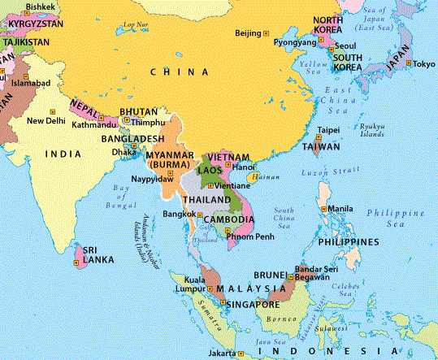
The media is full of articles regarding the current development in Myanmar. Especially in western media a picture is drawn of Aung San Suu Kyi, “democratic” role model and “hero” (even awarded with the Nobel Peace Prize), as a victim, brutalised by a coup staged by the military fiends. But what really goes on in Myanmar lies behind a curtain of silence – ongoing armed struggle (ever since colonisation by the British), led by various factions, ethnicities or groups against the reign of succeeders of British colonialism. This is of our very interest, because this once again proves the unevenly developing revolutionary situation in every country and on world scale and that the oppressed nations are storm-centres of world revolution.

It should be borne in mind that the legacy of colonialism, which arbitrarily drew the borders of the colonies, following its principle of "divide and rule" and pitting one people against another in order to maintain its domination, constitutes the local causes of the conflict, because the superpowers and powers act through the manipulation of these contradictions which come from the colonial past and which are used to cover up the fundamental contradictions of these societies, which are: mass-feudalism, people-bureaucratic capitalism and nation-imperialism. In order to divide, the imperialists encourage ethnic struggles by promoting "ethnically pure" entities (as in ex-Yugoslavia, for example); the imperialists, reactionaries and revisionists conceive of minorities only as distinct ethnic realities in order to go against national unity; that is to recognise only a part of them in order to subjugate and oppress them.

It is up to us to apply the theses of comrade Stalin on the national question, who states that in order to define a nation, four characteristics must be seen: unity of language, unity of territory, unity of economy and unity of psychology, the latter being concretised in culture; for Marxism, it is capitalism that is the process that drives nations. That is why we say that the oppressed countries of the Third World are nations in formation, and only with the triumph of the democratic revolution and the uninterrupted continuation to the socialist revolution will we culminate this process of nation building. There is a lot of gossip about the recognition of their rights, but this is separated from the right to have their own territory, because in the end they reduce nation to culture, national questions to cultural identity. The case of the "Plurinational State" is very expressive, conceived by imperialism and implemented through its NGOs, to oppose class with "ethnicity", to seek to isolate the proletariat from the peasantry in the democratic revolution and subject them to that landlord-bureaucratic dictatorship in service of imperialism disguised as a "Plurinational State". Against this trafficking to subjugate minorities and to divide the people, we propose the right of minorities to be autonomous, which includes the right to separate. Marx puts forward the right to separation. Comrade Stalin, too. The right of separation is key. Which also implies the right to unite freely and obviously this is linked to a united economy that sustains them, an economic base that allows them to unite and not an economy that serves to exploit them. Lenin therefore said the right to autonomy is concreted in the right to freely separate.

Current Development

First we want briefly have a look at the recent events. All of which requires examining the complex plot to get an idea of who is or are behind the main participants on either side of the coup, and so on.

In short terms some representatives of the old big landlord bureaucratic state, in service of imperialism, was replaced, not by an electoral farce but by take over through the military authorities, declaring the state of emergency – arguing that its actions are in accordance with the constitution. The difference is in forms not content. Such handling of contradictions among the factions of the ruling classes is nothing unusual, at least in the Third World. Here we see that after elections these are contested by the military coup leaders, so we have two forms of change of government, by means of the electoral farce or the coup d´État; which, depending on the case, can give rise to a government of constitutional democracy (designated by means of the electoral farce) or a democratic government through the military coup; but it is also possible that by the two forms of change of government there is a change of regime, i.e. from demo-liberal to fascist and vice versa. There have been many examples in Latin America. Peru: coup d´État in 1962, gave rise to a demo-liberal government which prepared the transfer of government from Prado to Belaunde; military coup in October 1968, gave rise to the fascist government of Velasco Alvarado and then of Morales Bermudez, which then through elections gave way to the demo-bourgeois government of Belaunde; this through elections handed the government over to Alan García in 1985, who after the genocide against the P.O.W.s went on to develop a fascist regime; in the 1990 elections, the fascist García favoured the nomination of Fujimori, who began as a demo-liberal government with increasing fascist expressions, until with the "self-coup" of April 1992, with the bayonets of the armed forces, he established a fascist regime, a fascism suited to fight the People's War; a regime, which with successive changes of horses through elections remains in serious existential crisis until today.

Reactions Reaction

The British The Guardian published a supposed statement by Aung San Suu Kyi to oppose the military, heading “Civilian leader urges the public to protest”. It claims that “people flocked to cash machines and food stalls”, suggesting turmoil and disorder. It names the coup “everybody’s worst nightmare” and celebrates Suu Kyi winning “a sweeping election victory in November”. This election (resulting in 396 out of 476 seats, more than 80%, for the NDL) was called fraudulent by Suu Kyi’s counterparts and is the official reason for the arrests of mostly NDL members during the coup. The Guardian quotes people calling Suu Kyi “a national idol”, stating “The moment Suu Kyi comes out and gives the order to do something, people will probably comply.” Barbara Woodward, the United Nations ambassador for Britain, and Head of the UN Security Council for February intended “a range of measures” against the coup instigators. British imperialism is backing Suu Kyi and her “National League for Democracy” (NLD) strongly, thereby supposedly trying to close the ranks with Yankee imperialism.

But the Yankees went a bit further. Calling Suu Kyi a “heroine of democracy who would save her country from a fearsome army” back in the days, the New York Times blamed her being “a fallen patron saint who had made a Faustian pact” with the military, “failed a great moral test”, not being able to “protect her people, nor could she placate the generals”. It goes on: “… by defending the generals in their ethnic cleansing of Rohingya Muslims, she lost the trust of an international community [i.e. Yankee imperialism, the sole hegemonic imperialist superpower; annotation by ci-ic.org] that had championed her for decades.” She lost the support by the Yankees and a coup was staged. That sounds very familiar. But “the military must reverse these actions immediately”, said Secretary Antony Blinken and the new, old, Head of Yankee imperialism Joe Biden stated that the military should give up power, release detainees and refrain from violence against civilians. A strong condemnation sounds different and the Washington Post raised: “aggressive sanctions ... would punish ordinary people in Myanmar rather than its military leadership.” The reduced support by Yankee imperialism for Suu Kyi is connected with some progress of China in Myanmar, e.g. the deal of Huawei to build up the 5G-network or dam, pipeline and energy projects. The Washington Post explained the issue quite well: “The Chinese have warm relations with [Suu Kyi] that have deepened ... The military, on the other hand, is perceived as having a more independent streak that sought to balance against Chinese influence.”

It is obvious that “democrats” have issues openly supporting a military coup. Adherents to parliamentarism have to denounce such incidents formally. That seems to be the reason for the duplicity in the Yankee’s media. And that is what the UN and the EU did, transmitted by Italian La Republicca, who also in the first rows published the view of the now interim president Myint Swe who accused Suu Kyi for “attempt to usurp state sovereignty by illegal means.” António Guterres, General Secretary of the UN, stated: "These developments are a severe blow to democratic reforms in Burma … the clear will of the Burmese people to continue on the hard-won path of democratic reform … respect the will of the Burmese people and to adhere to democratic standards, any dispute must be resolved through peaceful dialogue.” “I strongly condemn the coup in Myanmar and call on the military to release all who have been unlawfully detained in raids across the country. The outcome of the elections has to be respected and democratic process needs to be restored.” said Charles Michel, President of the European Council. "The people of Myanmar want democracy. The EU is with them," added the head of European diplomacy, Josep Borrell.

Chinese social-imperialism, being weaker than wildly claimed, is a bit more cautious. “China is a friendly neighbor of Myanmar, and we hope all parties in Myanmar can properly handle differences under the constitutional and legal framework and safeguard political and social stability,” Wang Wenbin, spokesperson of Chinese Foreign Ministry, said on Monday. The Chinese Global Times described the military's actions as an “adjustment to the country's dysfunctional power structure”, calling both sides to reach “a compromise through negotiations to maintain peace and stability”. They also contradict reports on disorder in the largest city of Myanmar, Yangon: “everything is stable.” The paper warns about “possible external interference”, pointing at the Yankees: “The situation in Myanmar is likely to be an opportunity for the Biden administration … to repair relations with Myanmar, to make Myanmar problematic and use Myanmar to put pressure on China.”

Russian imperialisms first public stance via TASS was very restrained. Seeking not to choose a side Kremlin spokesman Dmitry Peskov stated it is “too early to make any preliminary assessments.”

Japanese imperialisms first statement on the recent events by Chief Cabinet Secretary Katsunobu Kato was also a cautious one. He stated that Japan is “confirming details of what has happened” and is calling “to peacefully resolve the dispute through dialogue while following the democratic process”.

The Indian The Hindus article is noteworthy. It wrote: “India does care about democracy in Myanmar, but that’s a luxury it knows it will not be able to afford for the time being.” This is an utmost cynical impudence as India is known as an awful prison of the peoples. But the newspaper reveals what India is concerned about: “India’s security relationship with the Myanmar military has become extremely close, and it would be difficult to “burn bridges” with them given their assistance in securing the North East frontiers from insurgent groups.”

Armed Rebellion everywhere at Hand

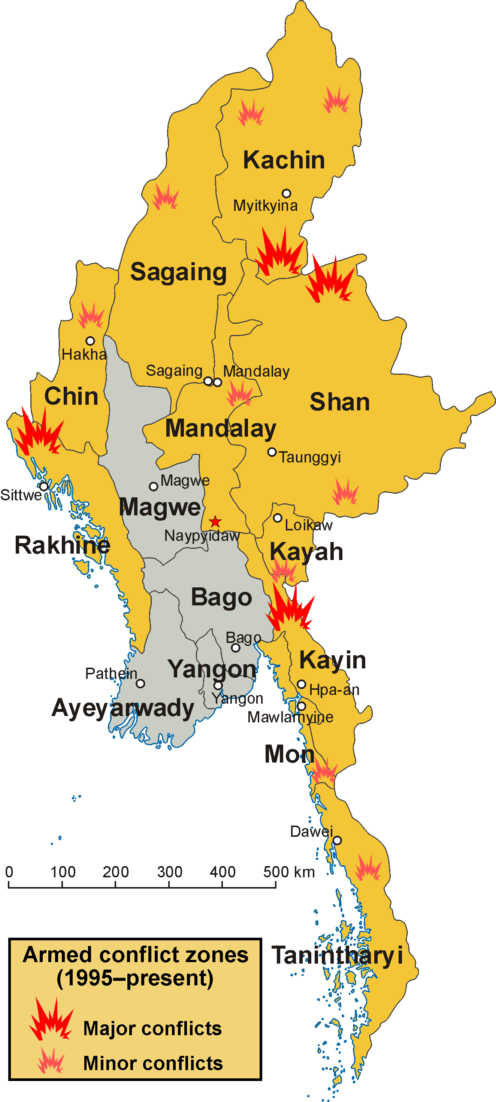
Myanmar once more validates the International Line of the glorious Communist Party of Peru. It states: “The need to see the contradictions serves to analyze the world situation and to define its strategy and tactics and within this its strategic and conflicting zones ... focal point in the immense strategic region of Asia, a region where great masses are concentrated, for example in India. If they sufficiently developed Communist Parties, it would serve to powerfully advance the revolution.” That is why the eyes of the world are on Myanmar, that is why Myanmar is on fire.

Further: “In the midst of a complex system of wars of all types, imperialism will be sunk along with world reaction, from which socialism will emerge; consequently, revolution and counterrevolution are conscious that only through war are political changes defined. Since war has a class character …”

It has to be concluded that in Myanmar there is a complex situation of contradictions between the different factions of the ruling classes in Myanmar and inter-imperialist contradictions under the hegemony of Yankee imperialism there– obviously handled by military means. Both, imperialism and the big landlord bureaucratic state, semi-colonialism and semi-feudalism, is a burden on the peoples of Myanmar and they have to get rid of them.

The people of Myanmar know about this and they are struggling. Proving Suu Kyi’s claimed “godlike status among ordinary Myanmar people” fraud and false, there are “decades of armed conflict … numerous casualties on ordinary soldiers. Desertion has been on the rise.”

In at least ten federal states there are remarkable armed rebel groups operating. Most well known among them is the Arakan Rohingya Salvation Army, since the genocidal atrocities committed by the Myanmar Army. The United Wa State Army has reached more or less fully independence/autonomy from Myanmar, due to an armed struggle for half a century (as splitters of the Communist Party of Birma). The Chin National Army, the Karenni Army, the Monland Restoration Army, the Shan State National Army, the Shan State Army-South are just a few examples for the ongoing big-scale national liberation struggle by various ethnicities in Myanmar. Neither the "civil government", nor the army was or will be able to solve this questions. There is a permanent status of civil war in Myanmar. Just two short examples: 1. The Kachin War is lasting for sixty years. In the past ten years thousands of civilians have been killed, whilst over 100,000 have been displaced. 2. The Karen War is an armed conflict in the Kayin State, known as one of the world's "longest running civil wars" since its beginning lies back in 1949, over 72 years ago. In the past thirty years around 4,500 people were killed and 200,000 were displaced. The Myanmar Armed Forces generally uses "scorched earth" tactics against the peoples to drawn rebellion in blood. They were alleged of burning down entire villages, the use of landmines and using civilians as minesweepers, systematic rape and ordinary torture, enslavement of civilians, extra-legal executions etc. It is the old tactic of genocide against the people, but the bloodshed does not drawn but spurs the revolution.

In a complex system of wars of all kinds in the immense strategic region of Asia, we see imperialism and world reaction in decline, in Myanmar, today. We see national liberation movements against imperialism and reaction, in Myanmar, today. Let us recall again the International Line of the CPP: “There are two currents that operate in the international Communist movement: The international proletarian movement and the national liberation movement. The first leads and the second is the base.” The basis is there, what needs to be created are the instruments of revolution under the command of Maoism, in Myanmar, today.

Foreign Intervention

Several foreign countries are or have been indirectly or directly militarily active in Myanmar. Back in the 1950ies the Yankees supported Kuomintang forces in Myanmar until they fled to Taiwan. China, Thailand, Pakistan are supporting or have been supporting various insurgents, French, Russian and British mercenaries are somehow present in Myanmar and the armed forces of the old Indian state invaded Myanmar after an attack of rebels in Manipur, although they have close ties and agreements with Myanmar, as written above. Social imperialist China seems to be the dominant imperialist power since it has financed and constructed paved roads for tanks and military supplies across the border, forming Myanmar as a transit-country to the Indian ocean, possibly as an alternative way out of the containment in the South Chinese Sea imposed by US imperialism and its "allies". Rumours said China built military bases (monitoring station and airport) on the Coco Islands (west of Myanmar) since 1992. But there is collusion and struggle among the imperialists. China and Singapore [i.e. foremost Yankee and British capital] share first position with each around 30% of total FDI in Myanmar. More than 30% of exports and imports are to/from China (18% exports to Thailand; 19% imports from Singapore, 13% from Thailand).

Basic Economic Facts

Myanmar is a kept backward, quite poor country, it ranks 147 of 189 in UN Human Development Index, with around 1,400 $ GDP per capita it ranks between Haiti, Zimbabwe, the Comoros and Pakistan, with a quite high inflation (up to 30% in 2007). Myanmar has as many inhabitants as England (around 55 million). Some 70 % are working in agriculture (child labour is common), 97% of produced food is rice. Myanmar is supposed to be the biggest producer of methamphetamines in the world. Just in 2002 opium and poppy farming was banned in northern Myanmar. Industry is mostly Garments, Resources are Gas, Oil, Gems (rubies, sapphires, jade and pearls), there are also some electricity projects like dams.

We are publishing this article on Myanmar, Asia, not only because of the topicality of the subject, but also because of the importance for the International Communist Movement and the development of the World Proletarian Revolution, i.e. everything that is happening in Asia and mainly because of the development of the People's War in India, led by the Communist Party of India (Maoist).

This refers to the case of the Danish NGOs that since the end of the 80s and during the 90s of the last century, worked in Bolivia applying the concepts of imperialist thinking of "postmodernism" to divert the struggle of the peasant movement for land towards the "problem of identity", dividing the peasantry by their geographical and ethnic origin. The Peruvian Marxist J.C. Mariátegui established that the problem of the Indian is not a problem of race but of land.
https://www.theguardian.com/world/2021/feb/01/further-army-clampdown-feared-in-myanmar-after-aung-san-suu-kyi-detained
ibid
ibid
https://www.nytimes.com/2021/02/01/world/asia/myanmar-coup-aung-san-suu-kyi.html?action=click&module=Top%20Stories&pgtype=Homepage
https://www.washingtonpost.com/world/2021/02/02/suu-kyi-democracy-myanmar-coup/
ibid
ibid
https://www.repubblica.it/esteri/2021/02/01/news/aung_san_suu_kyi_detenuta_dai_militari-285330118/?ref=search
ibid
ibid
ibid
https://www.globaltimes.cn/page/202102/1214556.shtml
ibid
ibid
ibid
ibid
ibid
https://tass.com/politics/1251211
http://www.asahi.com/ajw/articles/14153657
https://www.thehindu.com/news/international/news-analysis-with-myanmars-military-coup-the-tightrope-between-idealism-and-realpolitik-returns-for-new-delhi/article33720952.ece
https://www.washingtonpost.com/world/2021/02/02/suu-kyi-democracy-myanmar-coup/
https://www.nytimes.com/2021/02/02/opinion/myanmar-coup.html?action=click&module=Opinion&pgtype=Homepage
https://www.bbc.com/news/world-asia-india-33074773
wits.worldbank.org
data.worldbank.org
imf.org

